

|  |  |
| --- | --- |
| **Document description** | |
| **Document name** | User Needs Analysis Report |
| **Abstract** | This contains the content of the User Needs Analysis for the YEU project |
| **Document Identifier** |  |
| **Document Class** | Project Document |
| **Version** | 4.0 |
| **Authors** | Nathan Dodzo, Birmingham Ormiston Academy |
| **Contractual Date** | 1/11/2012 |
| **Creation Date** | 07/10/2013 |
| **Version Date** | 28/11/2013 |
| **Status** | Final |
| **Destination** | YEU Consortium |
| **WP number** | WP3 |
| **Related Documents** | **YENTELS User Needs Analysis report 2008** |

|  |  |  |
| --- | --- | --- |
| **History** | | |
| **Version** | **List of changes, Author(s)/Reviewers** | **Date** |
| 1.0 | First Draft publication | 28/11/13 |
| 2.0 | Updated with references | 13/12/13 |
| 3.0 | Updated with changes submitted by partners | 12/03/14 |
| 4.0 | Updated with minor changes | 13/03/14 |
|  |  |  |

Contents

1. Executive Summary 5

2. Overview/introduction (acknowledges YENTELS conclusions) 6

3. Methodology 7

1. **Aim of Research** 7

2. **How the Research Was Carried Out** 7

3. **Partners User Research Metrics & Experiences** 8

4. Findings of Quantitative Research 14

**1.** **Europe-wide statistics:** 14

• Youth unemployment across Europe: 14

• Youth Self-Employment: 15

• NEET levels across Europe: 16

**2.** **Partner Statistics:** 18

• Employment 18

• Pre-employment skills: 18

• Work Experience: 19

• Support pathways/networks: 19

**3.** **Business Start-Up Issues** 20

And 68% of respondents have thought about setting up their own business, but over half did not know where to get help on how to go about it: 20

• Marketing and accessibility of support: 20

• Finance: 21

5. Findings of Qualitative Research 22

1. **Employment** 22

2. **Business Start-Up Issues** 22

3. **General Qualitative Findings** 23

6. Conclusions of Research Study 24

1. **The European Policy Level** 25

• Governments are investing a lot into entrepreneurship and view this as having a role in dealing with high youth unemployment figures. 25

2. **Young People’s Employment** 25

3. **Pan European Employment Trends** 26

4. **Business Start-Up** 26

7. Recommendations 27

1. **Pan European Strategy Recommendations** 27

2. **National Level Recommendations** 27

3. **Recommendations for the YEU Project** 28

8. Profile and List of stakeholders 29

9. Bibliography and referencing 29

10. Appendix One – Youth Questionnaire 31

11. Appendix Two – Stakeholder Aide Memoire 36

**1.** **Questions for Young People** 36

**2.** **Questions for Entrepreneurs** 36

**3.** **Questions for Policy Makers** 37

**4.** **Questions for Employers** 37

# Executive Summary

Rising youth unemployment figures across Europe and the persisting current economic climate reveal, more than ever, the urgent need for our young people to develop the strategies and tools that will empower and enable them to successfully enter the job market. The goal of the YEU project, however, is to go further. In a climate where there is little choice in the type of jobs available and a mass of competition, we hope to inspire and assist young people to look to themselves as a resource- as an entrepreneur.

The report’s outcomes will help inform the content of online support materials that will help young people start their own businesses, and understand what is required to develop an entrepreneurial spirit, both in attitude and skill-set. Its findings will also help underpin the technical design of the YEU online e-learning materials and business game, and their ongoing process of assessment and development.

To this end, the research sets out to define the most important characteristics of young people’s entrepreneurship and employment training from across the participating countries and draw trends from a wider European perspective.

In doing so, the report analyses the results of research carried out by the YEU project partners into the entrepreneurship training needs of young people (employed, unemployed, in education and not in education or employment) as well as an analysis of the training needs of creative and IT business sectors, as these are the industries young people are likely to seek careers.

The conclusions of the Leonardo funded YENTELS (Young Entrepreneurs E-Learning Suite) project have also been included, to enable the YEU project to learn from the successes and challenges of its predecessor. Primary and secondary research methods were used and feedback has been gained from a total of approximately 40 stakeholders and 900 young people across Europe.

A range of quantitative and qualitative research findings have been identified in the areas of young people’s employment, business start-up options, with general research observations and research experiences also recorded by the partners. Conclusions have been made in the areas of young people’s employment, business start-up issues, pan-European employment trends and European policies. The report also provides recommendations at European and National level to reduce youth unemployment and encourage youth entrepreneurship.

Finally, it has a number of recommendations as to how YEU can proceed with the development of materials and on-line resources to ensure that these meet the needs of the young people and stakeholders consulted during the research.

# Overview/introduction (acknowledges YENTELS conclusions)

The YEU project will build on the findings and conclusions of the Leonardo funded online learning project: YENTELS (Young Entrepreneurs E-Learning Suite). Those most relevant to the YEU project are as follows:

* Higher education institutions should integrate entrepreneurship across different subjects and courses, notably within scientific and technical studies.
* Public authority support is needed to provide high-level training and to develop networks that can share good practice. A more dynamic partnership is required between the business world and education professionals which is heavily focused on the provision of young people’s education.
* Training material for the YENTELS project should be structured to mirror the levels of apprenticeship to ensure more relevance and adequate assimilation of the content by students.

In general, young entrepreneurs felt confident in their own knowledge about the specific industry in which they are involved, but also recognised the need to develop their business and management skills in order to run their own business successfully. Stakeholders and associations agreed, but noted more skills gaps, especially in accounting and finance, business planning, time management and human resources.

Business leaders are also acutely aware of the need to recruit skilled staff with specialist and technical expertise and feel is not easy to find them.

These conclusions from YENTELS will be used by the YEU partners to inform the development of the e-learning materials and business game.

# Methodology

## **Aim of Research**

The aim of the user needs analysis study is to help to clarify the needs of the users, stakeholders and training providers, in order to provide the YEU platform with e-learning materials that are fit for purpose.

The content of the initial YEU online course structure will also incorporate and develop existing YENTELS course materials, whilst using the research findings to tailor its design and marketing to ensure they are packaged in a manner that is most suitable for the target audience of young people.

The findings will also be used to influence other technical design considerations of the portal and business game, and assess the appropriateness of different types of emerging e-learning technologies for the target group in order to aid its development.

## **How the Research Was Carried Out**

The target research group included a specific focus on young people not in education or employment (NEET), young adults in formal education and those employed by SMEs and creative & IT businesses.

Birmingham Ormiston Academy, (BOA) with the support of the other partners provided the research framework & methodology which enabled the partners to carry out the research with young unemployed/employed people, and young people in education, and with other stakeholders such as entrepreneurs, policy makers & employers.

The research was carried out in Bulgaria, Italy, the UK, Poland, Slovenia, Portugal & Turkey.

The following table provides more details of the types of primary & secondary research methods used.

| **Action/Primary Research** | | **Desk/Secondary Research** | |
| --- | --- | --- | --- |
| Quantitative | Qualitative | Quantitative | Qualitative |
| Questionnaire | One-to-one interview | Surveys | Books |
| Surveys | Focus groups | Questionnaire results | Internet articles |
|  | Case studies | Third party database | Periodicals;  Newspapers, Magazines |
|  | Recorded interviews | Census | Documentaries and Biographies |
|  | Observation |  | Third party case studies |
|  | Testing |  | Research papers/journals |
|  |  |  | Archives, including video |
|  |  |  | Other Library resources; e.g. Microfiche |
|  |  |  | National Legislation and regulations |

A bespoke questionnaire was created for both stakeholders and young people, (see Appendix 1 and Appendix 2) and translated into their own language by the partner, who then prepared a summary report of the responses.

Research was carried out in three research cycles. A combination of desk research of existing literature and a range of primary research mechanisms - including one-to-one discussions / interviews, social media (i.e. Facebook), printed questionnaires and workshops were used. To help obtain higher quality results, many of the surveys were carried out by face to face interviews. The primary research was with both representative groups and the young people themselves.

This research was intended to help the partners identify skills gaps for young people and so determine the most effective training options & modules needed to overcome these gaps in knowledge.

It is anticipated that user needs analysis activities will continue throughout the project as the partners gather more research on user needs through a range of dissemination events. In this way, user needs analysis will be an exhaustive process that will see a significant level of contact & consultation with users and stakeholders in all seven partner countries.

## **Partners User Research Metrics & Experiences**

The Primary target group were NEETs with a minimum of 25 per partner country, with Secondary target groups identified as:

* + ICT, New media and trades based industries – minimum of 10 per partner country
  + Young people employed in SMEs – minimum of 10 per partner country
  + Young people in formal education – minimum of 10 per partner country

Partners also had to ensure that as a minimum they carried out consultations with at least 10 of the following stakeholder groups per partner country:

* + Young People Support Organisations
  + Government Organisations
  + Educational Establishments
  + Employers
  + Business Supports
  + Employment/Unemployment Specialists
  + Careers Advice

The key questions that the research aimed to answer were as follows:

* What local, regional and national opportunities/strategies have been put in place to respond to the high levels of youth unemployment?
* What support is available for young people wanting to set-up a business?
* What challenges do young people face when looking for a job or when starting a business?
* What factors have led to such high levels of youth unemployment?
* What do we need to do in order to improve the employability of our youth?
* What resources and tools are there available in assisting young to start-up and/or maintain a business in your country?
* Can Entrepreneurship contribute to high levels of youth employment?
  + If it can, what can we do to support young people in becoming successful entrepreneurs?

The following table provides an analysis of the numbers of respondents who were sampled.

|  |  |  |  |  |  |  |  |  |  |
| --- | --- | --- | --- | --- | --- | --- | --- | --- | --- |
| **Qualitative Primary Method** | **CWCC** | **DemoCentre** | **BOA** | **CPU** | **WSEI** | **Yeditepe** | **Edit Value** | **Start Up Bulgaria**  **(incl. Virtech)** |  |
| **Stakeholders** | 12 | 14 | 5 | 10 | 10 | 52 | 6 | 9 |  |
| **NEET** | 14 | 0 |  | 0 |  |  |  |  |  |
| **ICT, New media and trades based industries** | 19 | 5 | 16 |  |  | 1 |  |  |
| **Young people in formal education** | 20 |  |  |  |  |  |
| **Young people employed in SMEs** |  | 1 | 10 |  |  |  |  |
| **Total** | **45** | **39** | **22** | **10** | **10** | **52** | **7** | **9** | **189** |
|  |  |  |  |  |  |  |  |  |  |
|  |  |  |  |  |  |  |  |  |  |
| **Quantitative Primary Method** | **CWCC** | **DemoCentre** | **BOA** | **CPU** | **WSEI** | **Yeditepe** | **Edit Value** | **Start Up Bulgaria**  **(incl. Virtech)** |  |
| **Stakeholders** | 15 | 50 | 270 |  | 97 |  |  | 93 |  |
| **NEET** | 14 | 44 | 32 | 28 |  |
| **ICT, New media and trades based industries** | 13 |  | 2 |  |  |
| **Young people employed in SMEs** | 19 | 72 |  | 19 |  |
| **Young people in formal education** | 19 | 136 | 12 | 6 |  |
| **Total** | **80** | **50** | **270** | **259** | **97** | **46** | **53** | **93** | **948** |

Table shows all stakeholder groups that participated in the research

The breakdown of respondents by gender, age and status was as follows:

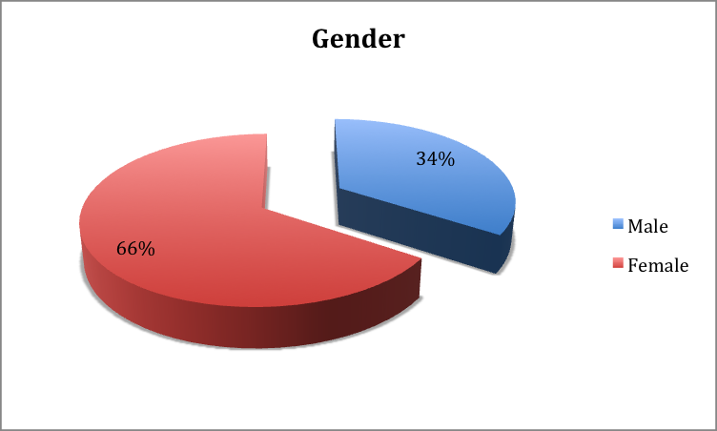

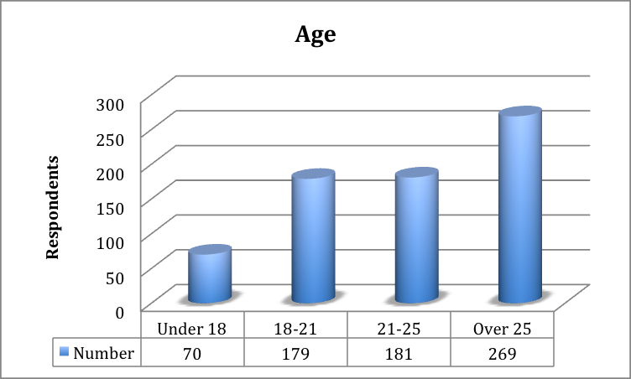



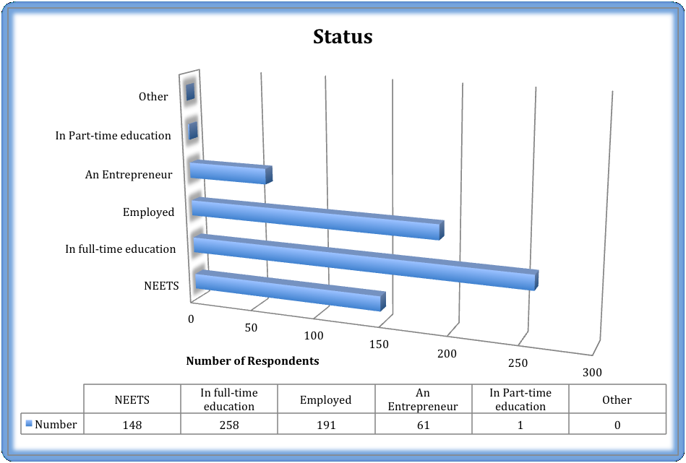

**Partners’ reports on User-needs research metrics:**

* In one-to-one interviews, CWCC engaged 19 young people involved in training, and an additional 13 people from the NEET category. A further 11 NEETS were engaged through a workshop.

From stakeholders, 2 job shop staff were interviewed, with 4 other stakeholders via one-to-one meetings, and an additional 8 via a Board Meeting. Shop vouchers were provided to those young people who carried out an interview.

* Democentre have engaged approximately 40 young people in their user needs research and relied on their close associations with the province of Modena and its universities of ‘Modena’ and ‘Reggio Emilia’ alongside other universities including Bologna and Parma. They found that youth unemployment is a very popular and current topic in Italy and it was not difficult to gain responses to their questions.
* BOA contacted their students (aged 14 – 19) and various other groups of young people, and gained approximately 270 responses through quantitative and qualitative research methods. Since they are an academy (school), they have excellent links with several stakeholders who work with young people and support them in the world of work and starting up a business.
* CPU used the innovative approach of contacting their colleagues’ sons and daughters via Facebook to gain their views on youth and unemployment and received 259 replies.
* As a university, WSEI asked their lecturers to talk to students about the project during lessons after which students completed the written questionnaires. As a result, they gained responses from 100 young people. They used their contact network with local & partner institutions to gain feedback from 10 stakeholders.
* Yeditepe achieved 46 completed written & on-line questionnaires from the NEET group, in addition to 5 interviews with young people and 3 interviews with entrepreneurs/ employers.
* Edit Value used interviews and written questionnaires to gain responses from 53 young people and 7 stakeholders. They found that the survey respondents were receptive to the project concept and feedback indicated the project brochure was very useful in explaining this.
* Start-up Bulgaria and Virtech used a combination of 9 interviews with stakeholders which included various organisations and personalities, and 93 online and offline questionnaires distributed through their communication channels and various events they organised.

**Partners’ reports on user needs research experiences:**

One partner expressed initial concerns that there were too many general questions in the survey, particularly when dealing with the NEET group. However, it seems that these fears were unfounded since the young people actively engaged with the research efforts.

Another partner did report “survey fatigue” from the young people they contacted as they often receive requests for participating in surveys which often turn out to be sales calls.

Another partner reported that it had edited the survey to make it quick and easy for young people to complete since they often do not have the time or the inclination to complete a long questionnaire. Many of the partners also translated the questionnaire from English into their own language so that the young people could give the most accurate and consistent answers.

This finding was supported by another partner who tried to use social media to gain feedback from young people. However, they found that this was not successful as it seemed that young people became bored completing questionnaires or carrying out voluntarily tasks that took them more than a few minutes.

Some partners found that many of the stakeholders were too busy to participate in the research.

One partner pointed out that whilst it was sometimes difficult to reach the young people to engage them in the research, once they had made contact they were interested in the topic and keen to contribute their feedback.

The lack of a tangible project outcome such as a business game or on-line learning materials meant that one partner could not find out from the target group what obstacles in content development could be encountered as the project progresses. Another reported that this issue meant that the young people were less interested in completing a questionnaire about a concept rather than a tangible product.

# Findings of Quantitative Research

## **Europe-wide statistics:**

## Youth unemployment across Europe:

The following charts are an indicator of the youth unemployment and employment picture across Europe, with the first chart indicating the sharp rise in youth unemployment since 2008. From the beginning of 2009, the gap between the youth and the total unemployment rates has increased, so that at the end of 2012 the youth unemployment rate was 2.6 times the total rate.

**Youth unemployment rates, EU-28 and EA-17, seasonally adjusted,**

**January 2000 - September 2013**

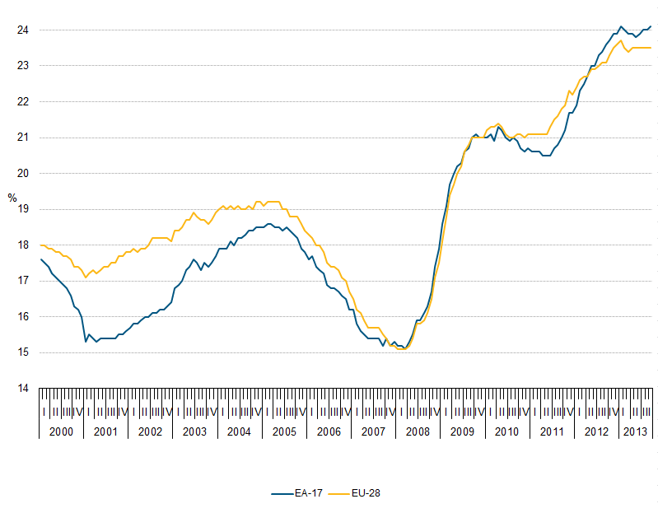

*Source:* Eurostat, June 2012

This manifests itself in the chart below as a significant decrease in the number of young people employed across all sectors, with huge drops in numbers in Construction, Manufacturing, IT and the Financial sector. Only Health and social work, and the education sector report an increase in numbers.

**Percentage change in youth employment, by sector, 2008–2011**



*Source:* Eurostat, July 2012

The chart below also indicates that of those young people in employment, part-time work has increased rapidly across the vast majority of EU countries:

**Part-time workers as a proportion of total youth employment, 2007 and 2011**



*Source:* Eurostat, June 2012

## Youth Self-Employment:

Among the 19.4 million young people in employment, the overwhelming majority are employees– 18.1 million in 2011. In 2011 only around 802,200 young people, 4%, were self-employed, while a further 511,000 worked in a family business. This last group is concentrated mainly in Greece, Poland, Romania and Slovenia.

Despite the decrease in the number of people in employment, the share of self-employed young people has remained almost constant over recent years.

## NEET levels across Europe:

As part of our research we made a conscious effort to give a specific focus on the most vulnerable group of young people i.e. NEETs (young people Not in Employment, Education or Training.) as a result a significant proportion

In a recent report by the European Foundation for the Improvement of Living and Working Conditions: (NEETs: Characteristics, costs and policy responses in Europe) the composition of NEET populations in different European Member States were clustered into four groups (see map for further details):



**Cluster 1:** (UK, Scandinavia, Holland, Germany) Characteristics of the first cluster included a high share of inactive workers. Many NEETs have work experience and they are often low skilled. There are few discouraged workers in these countries

**Cluster 2:** (Bulgaria,Greece, Hungary, Italy, Romania, Poland and Slovakia) displayed high NEET rates, with a high proportion of female NEETs. NEETs here are mostly inactive and without work experience. A large share is highly educated, and many are discouraged workers.

**Cluster 3:** (Estonia, Ireland, Latvia, Lithuania, Portugal and Spain) comprises countries that have been most badly affected by the crisis. They have high NEET rates and a majority are male. NEETs are mostly unemployed, but often have prior work experience. Countries in this cluster have a high number of NEETs with a high skill level and a high share of discouraged workers.

**Cluster 4:** (Belgium, Cyprus, Czech Republic, France, Luxembourg and Slovenia) is rather heterogeneous but displays below average NEET rates. Most NEETs are registered as unemployed and have previous work experience. There are few discouraged workers and NEETs have, on average, a medium skill level.



## **Partner Statistics:**

**Key Partner Stats**

**Slovenia**

56% of young people (respondents) do not have an updated CV

**Poland**

64% of respondents indicated that they thought lack of jobs available was the most often indicated barrier to getting ideal job.

**Italy**

Youth unemployment in recession-hit Italy crossed the 40% mark for the first time in August 2013, when 40.1% of 15-to-24-year-olds on the job market were out of work

*(National statistics agency Istat)*

**Bulgaria**

More than 77% of respondents declared that did not have the opportunities for vocational (learn a trade) study during the school experience

**Portugal**

81% of young people (53% of which were NEET) indicated Lack of available jobs as the most often indicated barrier to getting their ideal job, with 38% citing the main barrier as a lack of work experience.

**Turkey**

60% of the NEET group have received some form of vocational training whereas 40% have not.

**UK**

84% of the young people surveyed said that they use the internet to access job opportunities

Each partner has written their own country report which details their findings from the above research. The following represent a summary of this information.

## Employment

In terms of young people’s experiences and expectations of employment, the quantitative research revealed the vast majority of respondents planned to continue in training or education, or acquire more skills:

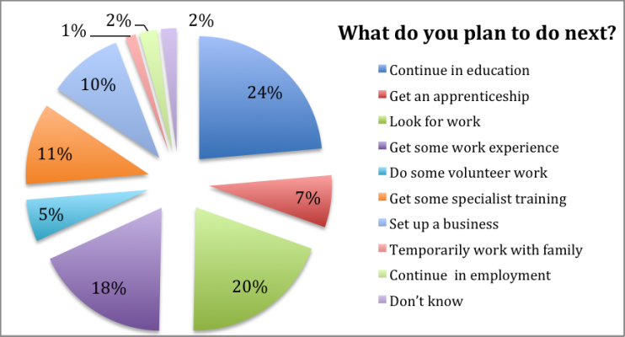

And a significant majority of these respondents had no opportunities for vocational study at school:

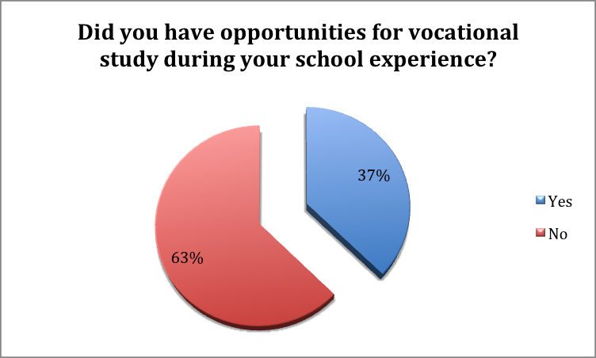

## Pre-employment skills:

A large proportion of young people felt that they received inadequate careers advice at school, which led to unrealistic expectations of the job market. They also reported not knowing how to prepare for or perform at interviews, and lacked the necessary knowledge of interview techniques, and communication skills to perform well.

Most young people did not know what a good CV looks like, and those who have one do not keep it up-to-date.

The vast majority of respondents commented that they have IT skills. Interestingly, the stats show that not all of them utilised these skills to create a CV.

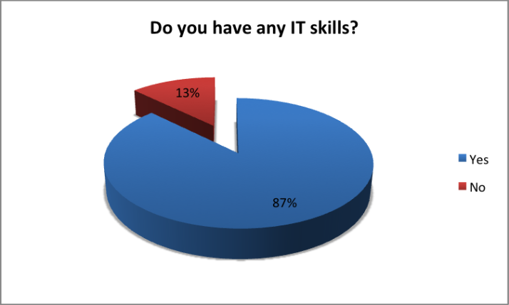

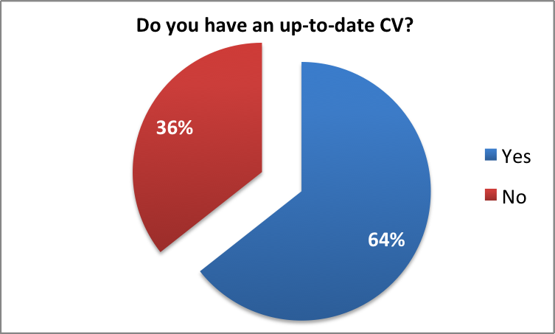

Following on from this, a significant majority of respondents reported not receiving any careers advice whatsoever:

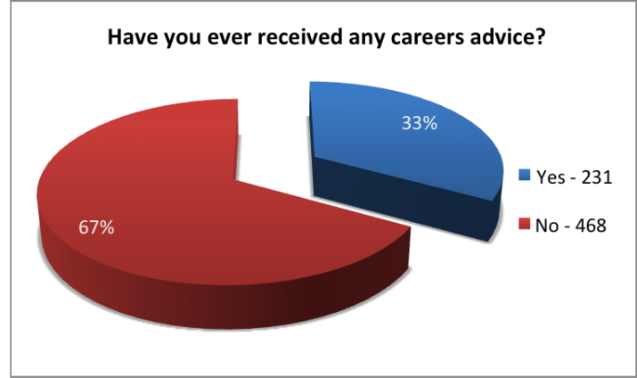

## Work Experience:

A large percentage of young people surveyed had NO work experience, even voluntary work – leading to inexperienced and unskilled graduates and young people.

## Support pathways/networks:

In the rural areas (in most partner countries), young people have the desire to set-up their own businesses but are encouraged to advance to university and are not given other options. In Poland the situation is different, young people are advised to follow a vocational route and start work as soon as possible.

While in the city, a notable percentage of young people want to work and earn a ‘Good’ wage. 95% plan to go to university and 40% of these want to set-up their own business, however 70% believe that there is information on other options post 16.

## **Business Start-Up Issues**

**Key Partner Stats**

**Slovenia**

35% of young people have thought of establishing their own business, even though 48% stated that they have their own business idea.

**Poland**

82% of respondents do not know where to find help on how to set up a business.

**Italy**

40% of respondents knew where to seek professional advice when setting up a business, however, 72% of would find it more useful to have access to a network of business mentors

**Bulgaria**

70% of respondents say they have their own idea for doing a business but only half of them know where to go and get help on how to set up a business.

**Portugal**

More than a half of respondents thought about setting up a business (64%), but more than a half of a survey group does not have a business idea (62%).

**Turkey**

All respondents have considered starting a business and have an idea for a new business but almost 80% of them do not know where to get help from in case they wanted to start a business.

**UK**

79% of respondents (42% of which were NEET) said they would you like to run their own business.

## And 68% of respondents have thought about setting up their own business, but over half did not know where to get help on how to go about it:

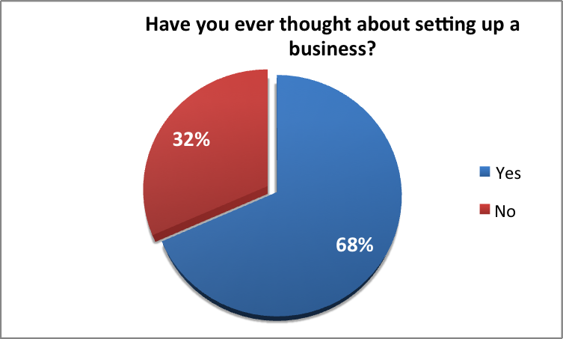

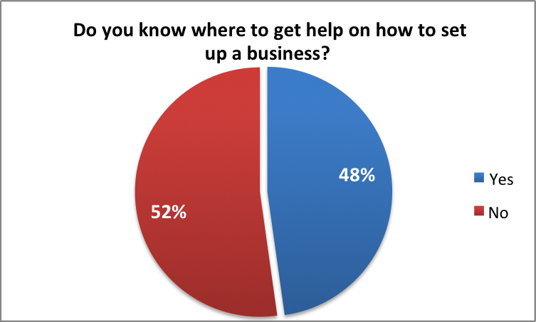

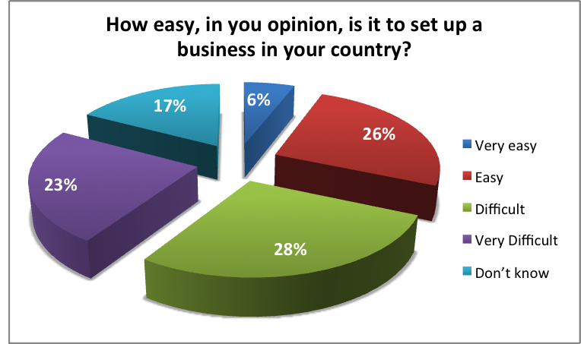

68% of respondents also thought that setting up a business was either difficult or very difficult, or didn’t know:

## Marketing and accessibility of support:

Despite the research indicating that many Higher Education institutions have set-up business incubation units to support enterprising graduates, the quantitative research also showed that a large percentage of young people would like to set-up a business, but don’t know how to go about it. In particular, young people do not know where to go for support when wanting to set-up a business.

This point was illustrated when students were asked about knowledge of YENTELS. 100% of those questioned (a sample group of 37 students from BOA) had no idea of the project and on-line resources that are available. (611 hits since 2008)

## Finance:

Young people were also unsure how to deal with financial issues when setting up a business

**Poland**

Cultural expectation and geography impacts on aspiration, opportunities and inclusion. Young people from rural areas do not think about setting up their own business, or even going to university. Most go to vocational schools to get a proper profession and start working and earn money in order to help their parents as soon as possible (as many families from rural areas are not rich). This is exarcerbated by infrastructure problems: In Poland, internet access, particularly in rural areas, is very poor so you cannot guarantee good on-line learning access to all young people. At least 80% of young people in all Countries (other than Poland) can get good access to internet.

**UK**

The Association of Colleges’ President Michele Sutton describes the quality of [careers](http://mail.aol.com/38203-112/aol-6/en-gb/Lite/MsgRead.aspx?folder=Inbox&uid=33200960&seq=4&searchIn=none&searchQuery=&start=0&sort=received&sortDir=descending##) guidance in schools is ‘nothing less than appalling’. Another report from the Institute of Public Policy Research IPPR has promoted a new plan to ensure all young people are either in paid work or in education.

Recent attempts to address youth unemployment (the DWP Work Programme and Youth Contract) is seen by employers as somewhat lacking. Therefore the full impact of its aims and ambitions has not been realised to the level required to make a significant difference to the lives of young unemployed people.

Too many professions were demanding degrees as a minimum entry requirement, suggesting university qualifications were actually “superfluous” to many jobs. **Vince Cable, UK Business Secretary**

Private school pupils should consider alternatives to university and stop being “sniffy” about getting a job at the age of 18… parents and teachers need to embrace “alternative avenues” such as an apprenticeship instead of aiming for Oxbridge and other top Russell Group universities.

**Hilary French, president of the Girls’ Schools Association.**

*‘Hurst, G (2013) ‘Don’t be Sniffy about work Skills, head says’ - The Times, November 19th*

**Italy**

The efficiency of the vocational training system in Italy suffers from structural problems due to an overly-rigid public and private organization with few interconnections with the schooling system.

The systemic flexibility required for labour market accession plus the lack of farsighted policies for education and training, are a roadblock on the path to employment for the Italian youth. Young people are at risk of economic and social marginalisation and from the erosion of skills and know-how traditionally acquired during their careers.

**Turkey**

Young people state that they generally do not feel that they have had a useful and effective work experience during their education.

Young people have received career advice, but mainly from their family elders and not professional mentors.

**Slovenia**

One of the problems for youth unemployment is an inconsistency between educational programs and labour market needs. Youth is getting trained in the fields that do not offer enough work placements.

**Portugal**

The great majority of stakeholders considered that young people are not prepared to enter the job market, because of inadequate academic preparation; Immaturity; Professional inexperience.

The most pointed solution to the youth unemployment, shared by all entrepreneurs, is the promotion of entrepreneurship in schools.

**Bulgaria**

Dual education systems are dependent on close cooperation between the public and private sectors, with a high degree of involvement of the social partners. ThoseEU countries with highly institutionalised interaction between the education system and the labour market have strikingly low levels of youth unemployment.

**Key Partner**

**Qualititive Findings**

# Findings of Qualitative Research

## **Employment**

In terms of young people’s and employer’s experiences and expectations, the qualitative research indicated that:

Employers:

* Graduates and young people’s skill levels do not meet the needs of their business, particularly in the area of ‘communication and interpersonal skills.’
* The current economic climate does not stimulate young people to view independent entrepreneurship as a viable career path. The lack of initial funding is a main barrier to starting a business.

Graduates:

* Feel cheated by their qualifications. They are seen as a risk by employers, who have little confidence in the skills of new graduates and instead opt to retain and retrain their existing workforce.
* Research from most of the partner countries shows that young people don’t want to do the jobs currently available on the market and find them unattractive. They feel that applying for an unattractive job defeats the entire purpose of going to university.
* Young people have unrealistic expectations of entering the job market

## **Business Start-Up Issues**

The qualitative research on business start-up issues shows that:

* Young people with entrepreneurial aspirations from both urban and non-urban areas felt they were signposted towards University despite this not being their preferred development route. Those with poorer grades were shepherded into manual jobs.
* A greater need for vocational study was expressed, especially for those engaged in the Arts, with a specific focus on incorporating a business element in their chosen area of study.
* The business training currently available needs to be more vocation-based: Young people feel they gain more in business practice and application when learning is experiential and contextualised, rather than through an academic approach. For example: writing a business plan can easily be done in a classroom, however, putting it into practice and sticking to it in the world of business is quite another.
* There is a growing demand for freelancers and self-employed professionals in ICT and the Arts.
* Current business training and support only partially meets young people’s needs, particularly if they want to set up their own business.

## **General Qualitative Findings**

Feedback from the evaluation questionnaires indicates that the partners have learnt that young people have more business knowledge and initiative than the partners first assumed.

**Marian Davies on interviewing students about their plans for life after BOA 2013**

As part of a bigger piece of research being undertaken for BOA, I am privileged to be working with a small sample group of Year 13 Creative and Performing Arts students. We have met regularly since they joined the academy as its first cohort in September 2011.

I recently interviewed an even smaller group of students who are not applying for higher education and training this year (2013) about their choices and destinations.

The year 13 students who are applying for courses are mainly applying for 2-3 years of further study at a university or vocational school which will be mapped out for them in terms of coursework, and lead to a qualification.

The students were interviewed individually. I asked them whether or not they had thought about putting together an action plan outlining the next 2-3 year, what it might look like and what they might need to include. Apart from one student, the majority had not thought to put an action plan together (yet) though they had some ideas about what it would include. They listed targets, deadlines, research, contacts, aspirations as details to include. The majority were not sure where to start with such a plan and when asked, all said they would appreciate support in putting something together.

The students in the sample intend to use social media, websites, CVs, ‘open’ events and personal contacts to publicise and market their skills. some were more confident than others about this, in particular, developing websites. Two of the students already have their own websites.

Funding and financing a continuation of their hopes and dreams is an issue for all of them. Some have jobs to support themselves (in restaurants and retail) some do not. When asked about the possibility of setting up their own business and entrepreneurship most of the sample group had very little idea about how to go about it and some felt they would be more interested in finding out more.

All of the students in the group expressed a determination not to give up.

In addition, any materials on business start-up need to be presented in a visually interesting and interactive way, which includes an interactive process of design, testing and development with its target users, with materials and game versions subsequently adapted and improved according to target group feedback. This is all the more important for the NEET group, who have a wide range of diverse needs that must be better reflected in the design of materials.

Lastly, European Government initiatives which tackle unemployment amongst 18 -24 year olds and support entrepreneurship suffer from a lack of coordinated efforts between stakeholders. This could have significantly reduced the ability to identify and meet the employment shortages and effectively target the young people who should be the intended beneficiaries of the majority of these schemes.

**Key Partner conclusions:**

**Slovenia**

It is very important to inform the young people about deficitary professions on the labour market which will help them to decide which professions will allow future jobs and successful careers

**Poland**

Support to vocational education should lower the age when young people enter labour market currently at 22 down to 20. However in the opinion of stakeholders at the moment there is lack of coherent strategy on that matter.

**Portugal**

Educational programs need to be adapted to the market in order to reduce the unemployment.

Portugal has several mechanisms for financial help provided to young businessmen or entrepreneurs but we realized that most of them are not fully informed about every possibilities of funding or financial support.

**UK**

80% of young people will either work in small to medium sized companies or work for themselves.  However the school curriculum contains nothing about self-employment and indeed in all our colleges of further education there is no funding or support**.**

There is no evidence (found as part of this study) that there is a European-wide and transferable framework (or set of tools) for young people who want to start their own business.

**Turkey**

Young people in formal education widely agree that their education did not provide them with a valuable work experience or specific vocation; they thus have to receive further on the job training, or attend specific skill building seminars and workshops – often far away from their homes and at an expense. Online training materials, business simulation games and the like can provide an efficient and effective solution to the discrepancy between formal education and specific skill sets required by the industry.

# Conclusions of Research Study

**Italy**

Young people have very few prospects of having any control over their own careers, the organisation of their work and or the work environment, such that they are arguably more at the mercy of events than “masters of their destiny”.

**Bulgaria**

The NGO sector in Bulgaria receives almost no support by the country, preventing it from making a real difference in the sphere of promoting and supporting the entrepreneurship. Our StartUP Foundation is an organization based only on volunteers and YEU project is our first experience with such a profound project.

We believe that our common and sustainable efforts could improve the unemployment levels in our countries and we could exchange best practices and know-how so that we could help many startup companies become successful and sustainable business.

The research carried out by the partners provides a Europe-wide Training Needs Analysis Research Report which highlights the main trends and findings as follows.

## **The European Policy Level**

## Governments are investing a lot into entrepreneurship and view this as having a role in dealing with high youth unemployment figures.

* European leaders are implementing new schemes aimed at increasing work opportunities for young people and setting up initiatives to encourage entrepreneurship and boost youth employment. In June 2013, they pledged 6 billion euros over two years to ensure job creation, training, and apprenticeships for young people.
* The support structures do not seem to be achieving the intended results.
* A key European priority is to reduce NEET numbers. However attempts to achieve this have been widely criticized since the statistics show they are failing.

## **Young People’s Employment**

* Youth unemployment is in a dire state across Europe. As a result, young people who are academic are continuing in education as long as they can.
* University graduates and young people are often branded by employers as lacking the essential skills needed for work. It is argued that education establishments sometimes concentrate too much on students passing exams rather than equipping them with essential ‘life skills’. Indeed, the research showed that there is a large percentage of unskilled graduates, and this is certainly the business world’s perception.
* Following on from this point, graduates feel massively cheated by their higher education qualifications as employers have no confidence in graduate employees. This is leading to a high level of emigration as graduates see no other option of finding work.
* Opportunities for young people are changing. However, this view is, unfortunately not shared between much of the NEET population.
* There is a need to develop essential pre-employment training and employability skills and improve the quality of support available to young people wanting to enter the job market.
* A high number of young people lack the skills and do not have the experience to embark on a successful career.
* Young people don't seem to be attracted to the vast majority of jobs on the market, for example jobs that rely on physical work, those that aren’t considered reputable and less skilled employment in relation to their education.
* Those young people who are not so academic, lack the correct guidance and support to allow them to make the right career choices. Almost 98% of young people sampled in this research are computer literate, but a large percentage of those do not know how to effectively utilise these skills in order to secure employment, (e.g. to create a CV).

## **Pan European Employment Trends**

The research study has also identified the following pan-national European employment trends;

* Different regions have experienced a massive change in the types of jobs available on the job market, mostly shifting from manufacturing to service based on ICT skilled sectors. This has led to inadequate support into these new employment sectors.
* The current economic climate has made it harder for young people to enter the job market.
* There are high levels of migration between European countries in search of that ‘dream job.’
* There has been an increase in Zero Hour, fixed-term and part-time contracts leading to lower job security.

## **Business Start-Up**

* A vast majority of young people would like to start a business but don't know how to go about it or even where to start.
* Young people are put off by the processes and procedures one has to go through when starting a business.
* In most of the partner countries, young people are not aware of the support that is available to them. As such, young people look to or depend on their families to provide financial support when setting-up a business.
* Entrepreneurship is seen as an option to very few involved in the research we conducted.
* A lot more needs to be done to support educational institutions in encouraging, helping, supporting and guiding potential entrepreneurs.
* There are several initiatives and intermediary organisations out there to support young people into business, but their target audiences are unaware of their existence.

# Recommendations

As a result of the above research findings, the project proposes the recommendations for future actions and interventions in the following three areas

* At the Pan-European strategy level
* At national level to improve education, training and advice and guidance services for young people
* Within the YEU project to ensure that it develops on-line materials and resources for young people that meets the needs identified in the research

## **Pan European Strategy Recommendations**

Using the results of the research with young people across Europe and with stakeholders who work with young people, the project recommends the following actions at the pan-European level

* Implement a strategy that encourages the collaboration between education and business ministries of member states and the pan-European initiatives developed by the European Union.
* A unified strategy at national, local, and sector specific level that encourages interaction between young people, their schools, and the business world, with a view to increase understanding of basic business needs that a young person will be expected to meet, and an insight into future skills requirements in order to better inform decisions on career choices.

## **National Level Recommendations**

The project feels that each country in the project partnership should consider the implementation of the following recommendations, to improve the take-up of entrepreneurship among young people:

* The exposure of pupils to Careers advice and support, and business and entrepreneurship, earlier on in their school life.
* Ensure that there is clearer sign-posting to existing and future provisions of business start-up/support initiatives for young people.
* A more effective and signposted structure for Careers Advice, whether at school, further education, or third party training providers is needed.
* A more structured and diverse pathway into higher education and the job market should be created.
* Ensure there is a more targeted and effective marketing strategy to ensure young people and lifelong learning partners know about all the support networks available to support students.
* Young people are our best resource: Schools and business need to work closer together to ensure that resource is fit for purpose and targeted towards markets and employment sectors that can provide opportunities and development for our young people.
* An investment in supportive ITC infrastructure that increases access to opportunities and training, regardless of geography, i.e. internet access in rural areas.
* More vocational-based business training, with a focus on business set-up is needed. A practical level of business acumen is even more important for students who go on to work in the Arts sector as they will often be self-employed, have to manage their own tax-returns and accounts, learn how to be competitive in the business world, and seek out markets to work in.

## **Recommendations for the YEU Project**

The research has provided the following recommendations for the YEU project

* Continue research and development into YENTELs with a test group of young people to ascertain whether YENTELs is currently fit for purpose and user friendly.
* Develop a user-friendly resource for young people and ensure that it is fit-for-purpose.
* Ensure that on-line resources incorporate materials that improve employability, such as advice and guidance on interview techniques, communication skills, business etiquette, personal development, adaptable CVs.
* Carry out further analysis into previous studies and materials and use these as a platform to develop a Europe wide on-line resource that effectively reaches the key beneficiaries of member states.
* Carry out further research into a more accessible domain name other than: y-e-u.eu.
* Develop a marketing and publicity strategy that ensures the target audience has an awareness of YEU and the support and service it offers.
* Revisit current YEU online platform and make sure it is accessible and user-friendly.
* Implement more Quality Assurance mechanisms to ensure that risks to the success of the project are identified and mitigated sooner (for example a 6 month project evaluation, rather than an annual evaluation).

# Profile and List of stakeholders

For the profiles and lists of stakeholders for each partner, please see country reports in the annexes attached to this report.

# Bibliography and referencing

**Country user Needs Analysis from the following countries and partners with references**

P0: UK - Coventry and Warwickshire Chamber of Commerce

P1: Italy - DemoCenter-Sipe

P2: UK - Birmingham Ormiston Academy

P3: Slovenia - CPU

P4: Poland - WSEI

P5: Bulgaria - Virtech

P6: Turkey - Yeditepe University

P7: Portugal - Edit Value

P8: Bulgaria - Start-up

**Website**

*Eurostat* http://epp.eurostat.ec.europa.eu/statistics_explained/index.php/Unemployment_statistics (2013, October 29)

*Barclays Life Skills* http://www.barclayslifeskills.com (2013, June)

*BBC iPlayer* http://www.bbc.co.uk/iplayer/episode/b01skbpd/Panorama_Jobs_for_the_Boys (2013, June 4)

*Channel 4* http://4talent.channel4.com/people-development/for-3-minutes-2012 (2013, June 14)

*Green Champions* http://greenchampions.co.uk/2012/09/youth-unemployment-set-to-rise (2012, September)

*Elevation Networks,* http://www.elevationnetworks.org/bbc-panorama, (2013, June 4)

*National Apprenticeship Week* (2013) https://nationalcareersservice.direct.gov.uk/aboutus/newsarticles/Pages/Spotlight-NAWweek2013.aspx (2013, March 19)

*Leap,* http://leap.org.uk, (2013, June 4)

*The Poverty Site* http://www.poverty.org.uk/35/index.shtml (2013, May 8)

*Young People’s Enterprise Centre of Expertise Report(YPECOE)* http://yeuengage.files.wordpress.com/2013/06/ypecoe-report.pdf (2013, March)

**Articles**

Brooks, K. (2013) ‘New solutions to a new economic reality’, *Yahoo Finance,* April 5

Buchanan, R. (2013) ‘Starstruck teenagers fail to grasp the reality of future jobs market’, *The Times*, March 19

Chakrabortty, A. (2013) ‘Young appmakers can't count on a job for life’, *The Guardian,* April 22

[Fazackerley](http://www.theguardian.com/profile/annafazackerley), A. (2013) ‘What to do next if you're too cool for university’, *The Guardian*, March 18

Henley, J. (2013) ‘Young, qualified and jobless: plight of Europe's best-educated generation’, *The Guardian,* July 1

Malik, S. (2013) ‘DWP seeks law change to avoid benefit repayments after Poundland ruling’, *The Guardian*, March 15

Peacock, L. (2013) ‘Record employment masks shock rise in youth joblessness’, March 20

# Appendix One – Youth Questionnaire

**General info**

1. Age:

* Under 18
* 18 - 21
* 21 -25
* Over 25

1. Are you:

* Male
* Female

1. Do you live in:

* A major city
* A small city
* A town
* A village

1. Are you:

* Renting privately
* Living in social housing - Council
* Living with parents
* Paying a mortgage
* Other (specify)

1. Are you a carer?

* Yes
* No

1. Do you have any dependants?

* 0
* 1
* 2
* 3 or more

1. Do you have any disability?

* Yes
* No

1. Are you:

* Not in employment, education or training
* In full-time education
* Employed
* An Entrepreneur

1. What social media platforms do you use?

* Facebook
* Skype
* Twitter
* YouTube
* MySpace
* LinkedIn
* Other (specify)
* None

**Education**

1. Did you have opportunities for vocational (learn a trade) study during your school experience?

* Yes
* No

1. What is the highest level of education you possess (EQF - European Qualification Framework)?

* No formal education
* Level 1
* Level 2
* Level 3
* Level 4
* Level 5
* Level 6
* Level 7
* Level 8
* Other (specify)

1. What do you plan to do next?

* Continue in education
* Get an apprenticeship
* Look for work
* Get some work experience
* Do some volunteer work
* Get some specialist training
* Set-up a business
* Temporarily work with family
* Don't know

1. Do you possess any IT skills?

* Yes
* No

1. Do you have access to a computer at home?

* Yes
* No

1. Are you confident in using a computer?

* Yes
* No

1. Which of the following can you do?

* Create a word processing document
* set-up a spreadsheet database
* Digital imaging and manipulation
* Use e-mail
* Use specialist software (please specify)
* None of the above

**Work and training**

1. Have you ever been in employment

* Yes
* No

1. Have you ever had any unpaid/voluntary work?

* Yes
* No

1. Are you actively seeking employment?

* Yes
* No

1. What resource do you use for looking for work?

* Jobcentre
* Newspapers
* Internet
* Personal contact / networking
* Cold calling
* Friends and family
* Other (specify):

1. Have you ever received any careers advice?

* Yes
* No

1. Have you considered apprenticeships?

* Yes
* No

1. Do you have an up-to-date CV?

* Yes
* No

1. What sector is your ideal job within

* IT
* New Media
* The Arts i.e Digital Arts, Performing Arts, Creative Arts
* Administration
* Public service
* Retail
* Health and social care
* Construction
* Manufacturing
* Hospitality - travel and tourism
* Other (specify)

1. What barriers prevent you from getting your ideal job?

* Insufficient education
* Lack of jobs available
* Specific training requirements
* insufficient experience

**Entrepreneurship**

1. Do you have a bank account?

* Yes
* No

1. Do you know anyone who has a business?

* Yes
* No

1. Have you ever thought about setting up a business?

* Yes
* No

1. Do you have a business idea?

* Yes
* No

1. Do you know where to go to get help on how to set-up a business?

* Yes
* No

1. Do you think that one would benefit from having a business mentor?

* Yes
* No

1. What barriers do you think you would face when starting a business?

* Leadership and management skills
* Funding/money
* Security
* Responsibility
* Business advice
* Writing a business plan
* Understanding taxes
* Employing people
* Managing people
* Other (specify):

1. Do you know how to do the following?

* Write a business plan
* Do a cash flow projection
* Open a business account
* Raise money
* Do the taxes

1. How easy, in your opinion, is it to set-up a business in your country?

* Very easy
* Easy
* Difficult
* Very difficult
* Don't know

# Appendix Two – Stakeholder Aide Memoire

To improve the effectiveness of entrepreneurship training to young people living in those regions of Europe which has some of the highest levels of youth unemployment. This way they will be able to consider starting their own businesses as an alternative to unemployment or unsuccessfully applying for the few jobs available.

## **Questions for Young People**

1. Name
2. What is your ideal job?
3. Do you have an idea that you’d like to turn into reality? If so, what is it?
4. How are you going to make it happen?
5. How important is it to have an up-to-date CV?
6. Do you feel you had good and meaningful work experience at school?
7. Have you received any careers advice? If so, who from?
8. How do you think you would benefit from careers advice?
9. Tell us about interview
10. Is there something you’d like to change about society? How would you do it?
11. What do you think you’ll/would you like to be doing in 10 years’ time?
12. In your opinion, what is enterprise? [i.e. “Enterprise is……….]

## **Questions for Entrepreneurs**

1. Name of organisation
2. Description of business
3. How have you turned your ideas into reality?
4. What does it take to be a successful entrepreneur?
5. Was it difficult to put together a business plan?
6. Where did you get the capital to fund your business?
7. Would you ever work for someone else?
8. Would you see yourself doing something for free?
9. What challenges have you faced when running your business?
10. Do you have a mentor? If no, what difference would having a mentor bring to your business?
11. What makes a business grow and last?
12. What business training would you require?
13. What advice would you give to young people with good ideas?
14. Have you noticed any current trends in enterprise in this country? And what do you think is the future of enterprise? [i.e. young people/environmental issues etc.]
15. Is there such thing as an enterprising culture? If so, what is it?
16. In your opinion what is enterprise? [i.e. “Enterprise is……….]

## **Questions for Policy Makers**

1. Name of organisation
2. Description of organisation
3. What support do you offer to young entrepreneurs?
4. Why encourage young people to be enterprising?
5. Have you noticed any current trends in enterprise in this country? And what do you think is the future of enterprise in UK?
6. Is there such thing as an enterprising culture? If so, what is it?
7. In your opinion what is enterprise? [i.e. “Enterprise is……….]

## **Questions for Employers**

1. Name of organisation
2. Description of organisation
3. Why is there an increase in the levels of youth unemployment?
4. What needs to happen to improve young people’s employability?
5. What advice would you give to young people to make them more employable?
6. Why encourage young people to work?
7. What are the needs of the labour market?
8. What will help young people to get into work?
9. Are young people prepared for the workplace?
10. Would you say that you have an ageing workforce?
11. Have you noticed any current trends in youth employment/unemployment in this country? And what do you think is the future of youth employment in UK?
12. Is there such thing as an enterprising culture? If so, what is it?
13. In your opinion what is enterprise? [i.e. “Enterprise is……….]